1. Project Structure:

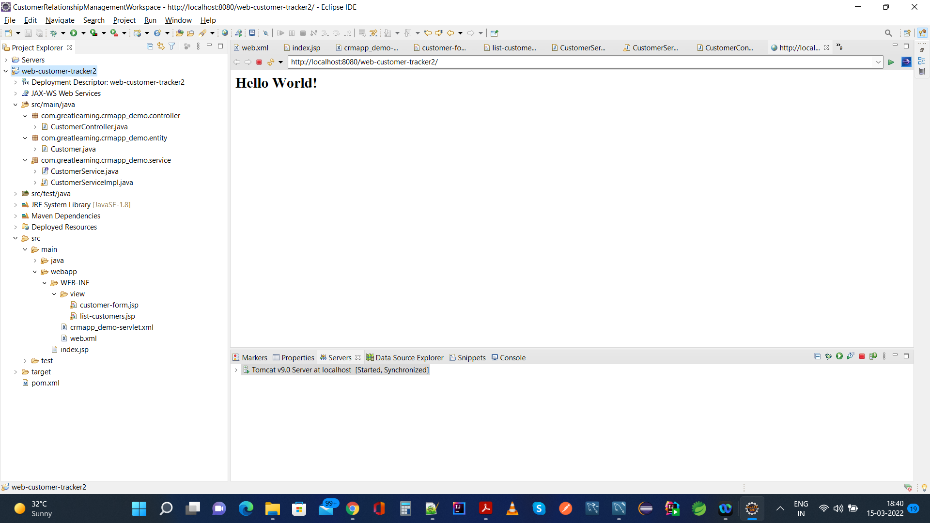

Project is developed using Spring MVC, HTML5, CSS, Hibernate with MySql

1. Home Page of Customer Relationship Management With No Data Initially is as seen below:

<http://localhost:8080/web-customer-tracker2/customer/list>

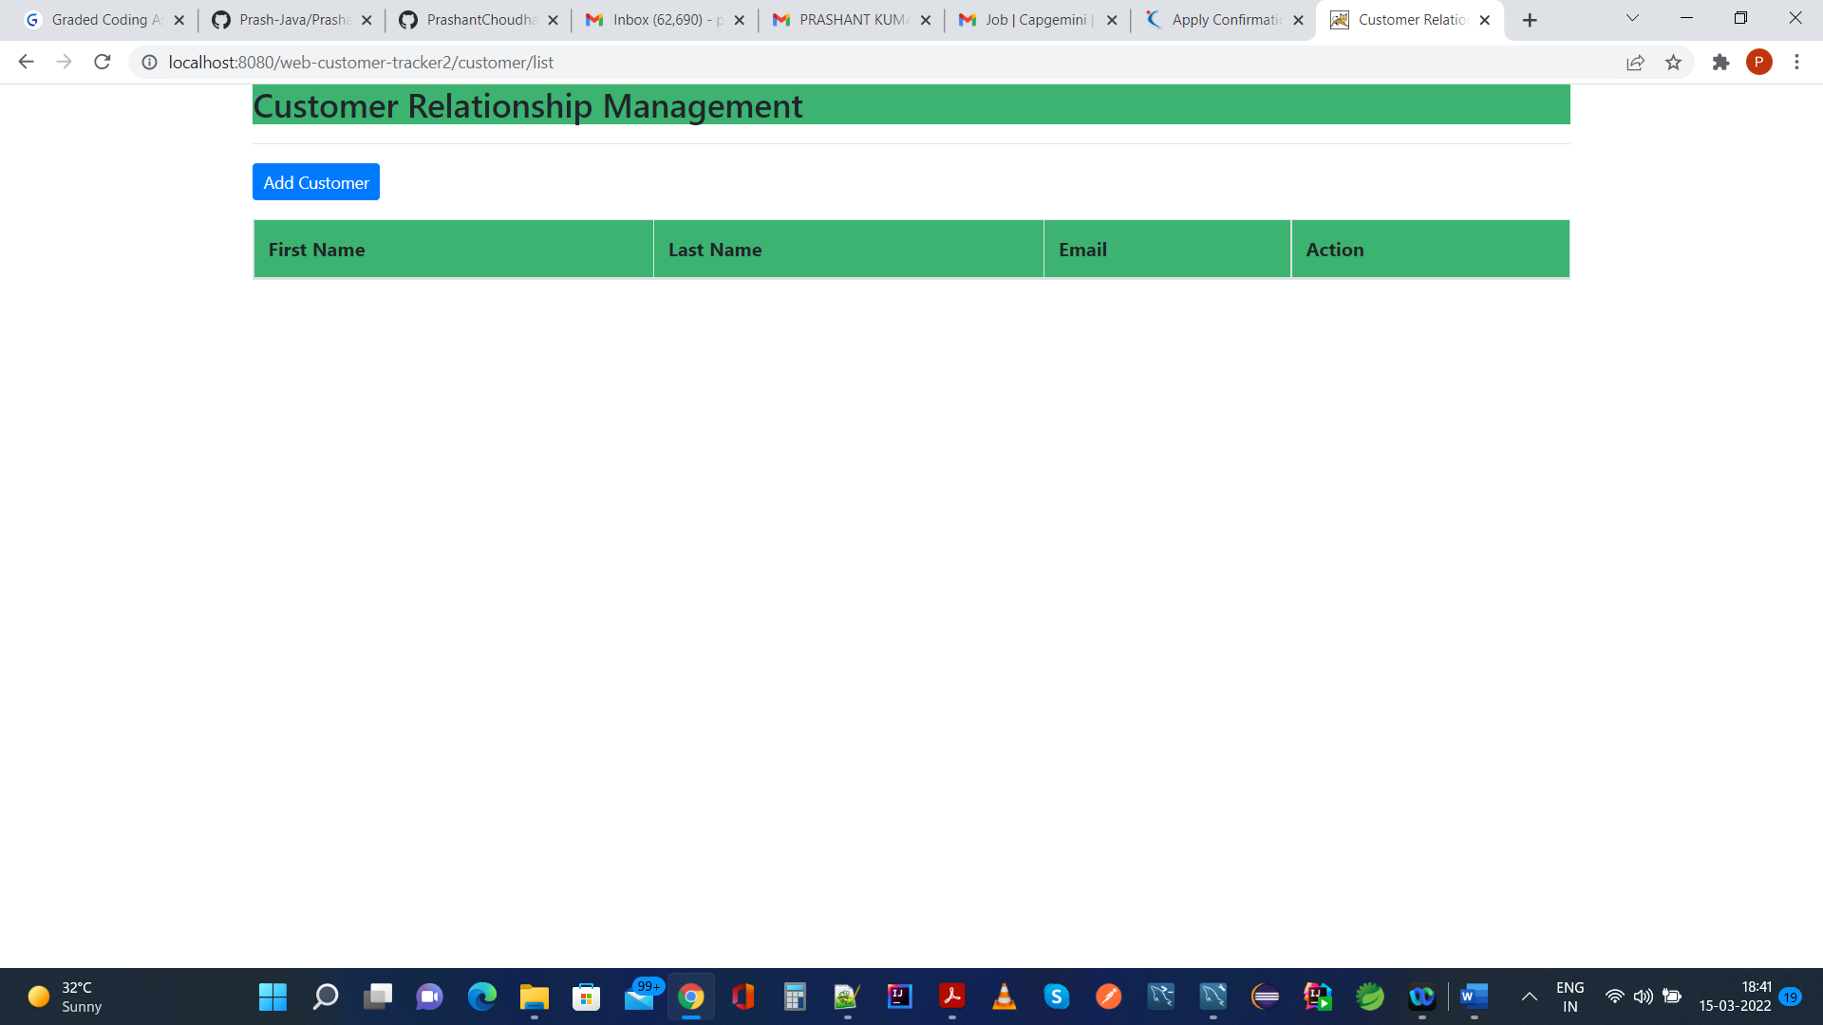

Similarly, Mysql database will also not have any record populated in table customer and is expected to be empty because we haven’t created any table manually or via entity class as seen below,

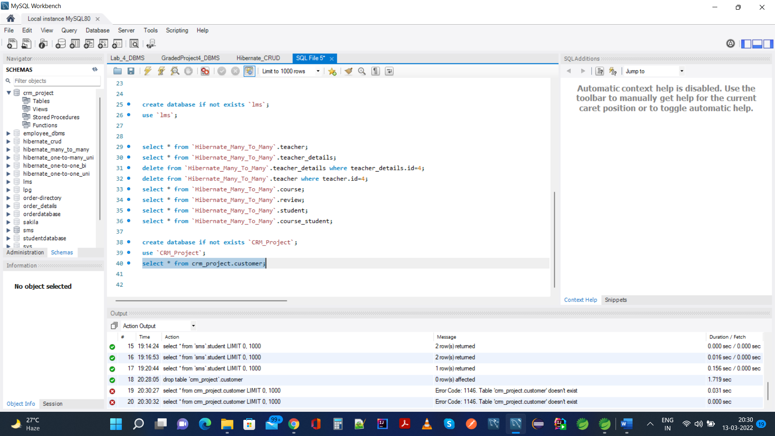

1. Functionality Add Customer is performed now as seen below, with application just started,

This navigates us to this url:

<http://localhost:8080/web-customer-tracker2/customer/showFormForAdd>

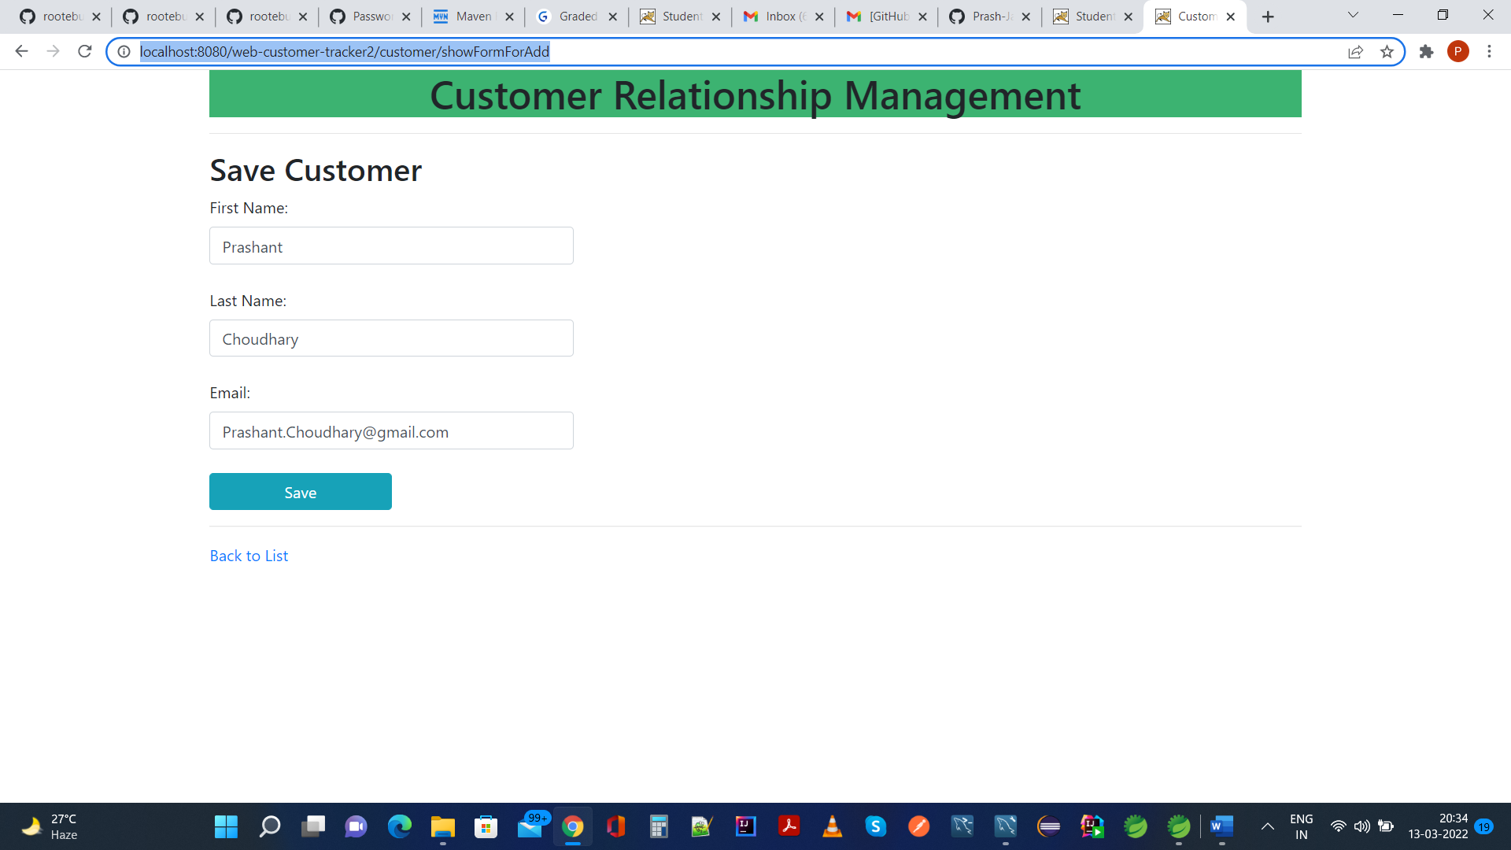

After Clicking On Save Button, it is expected that dataset will be added in DB as well as reflected in UI, during which application would redirect to following url:

<http://localhost:8080/web-customer-tracker2/customer/list>

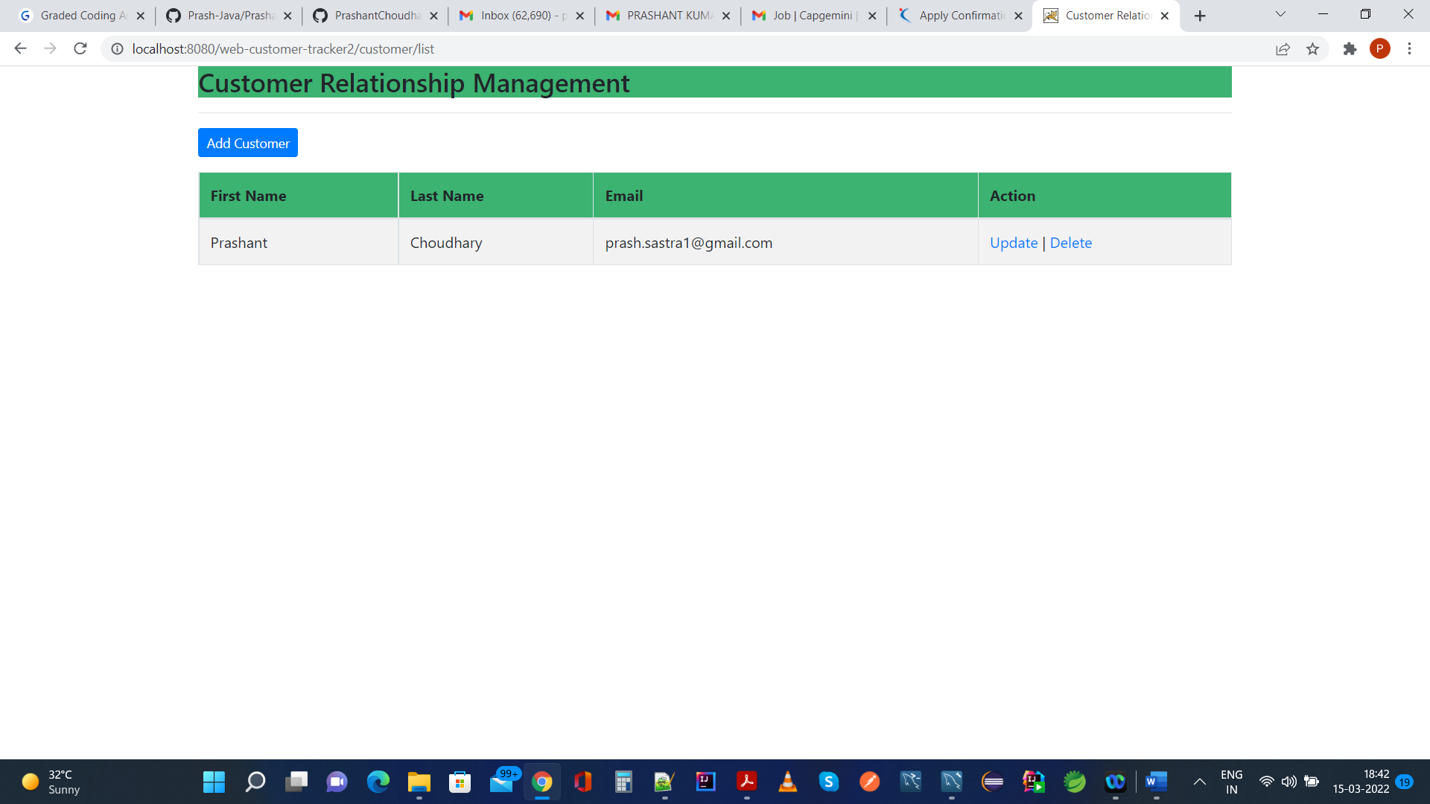

The MySQL Data table Customer is created and this resultset is present there as seen below, as we have added Customer,

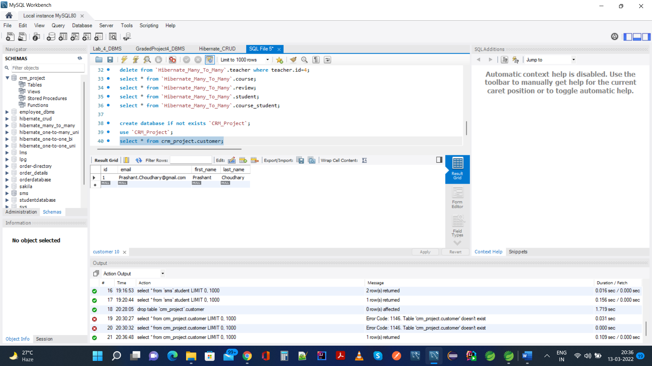

We would add another customer here just for testing the same functionality,

<http://localhost:8080/web-customer-tracker2/customer/showFormForAdd>

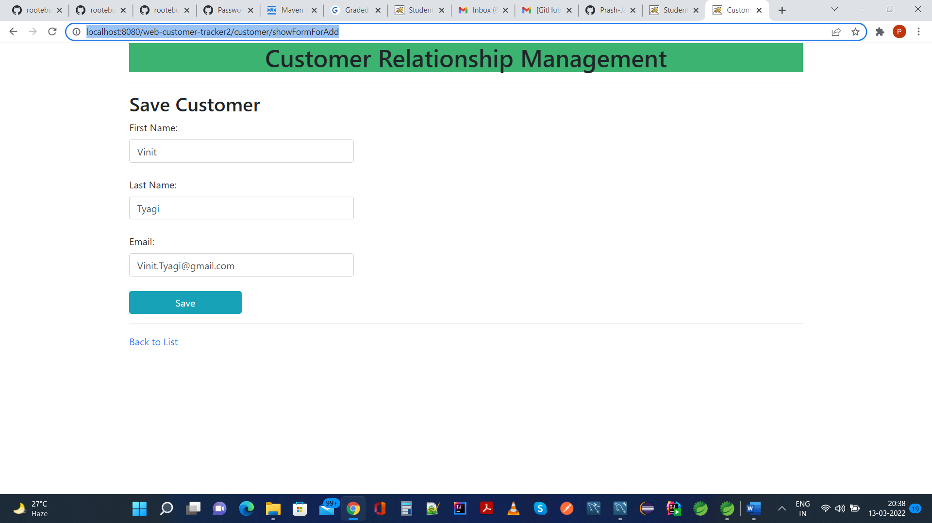

After Save operation, application would navigate to following url, and 2nd dataset is added successfully,

<http://localhost:8080/web-customer-tracker2/customer/list>

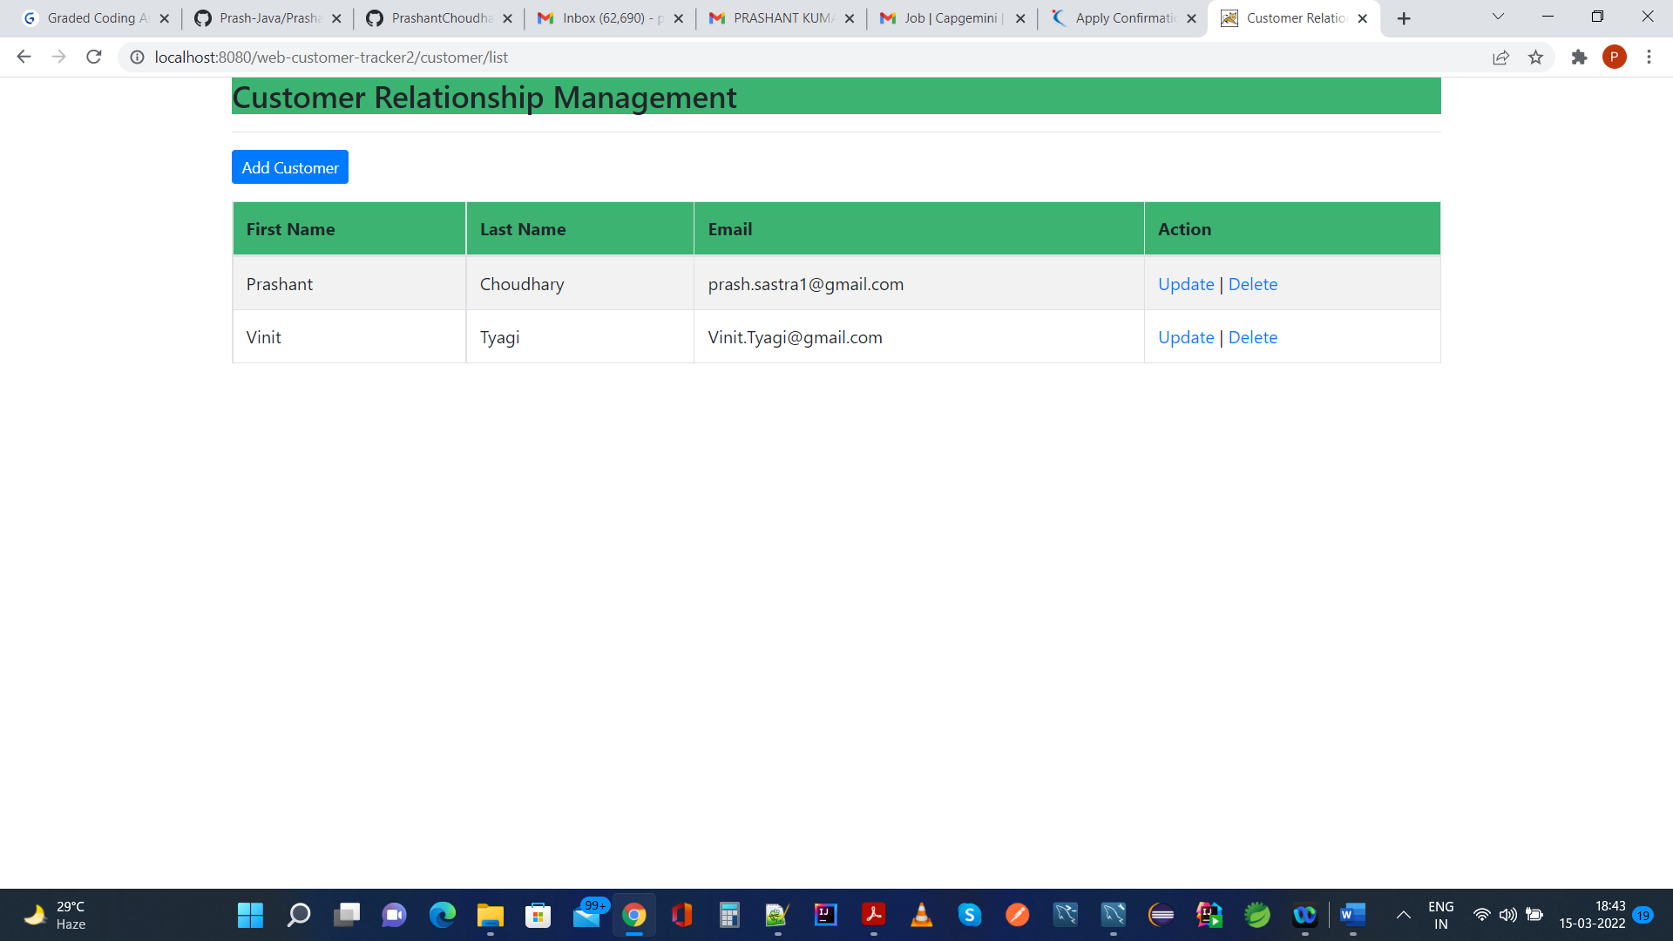

The same is reflected in MySql database as follows:

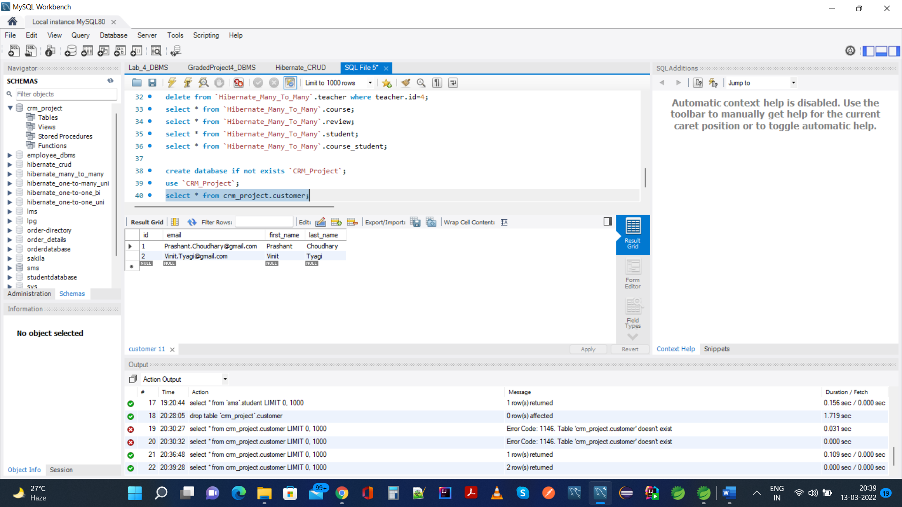

Back To List Functionality: two possible navigation to reach here:

1. Add Customer: On <http://localhost:8080/web-customer-tracker2/customer/list>

If we click on Add Customer Button, it would navigate us to the following url,

<http://localhost:8080/web-customer-tracker2/customer/showFormForAdd>

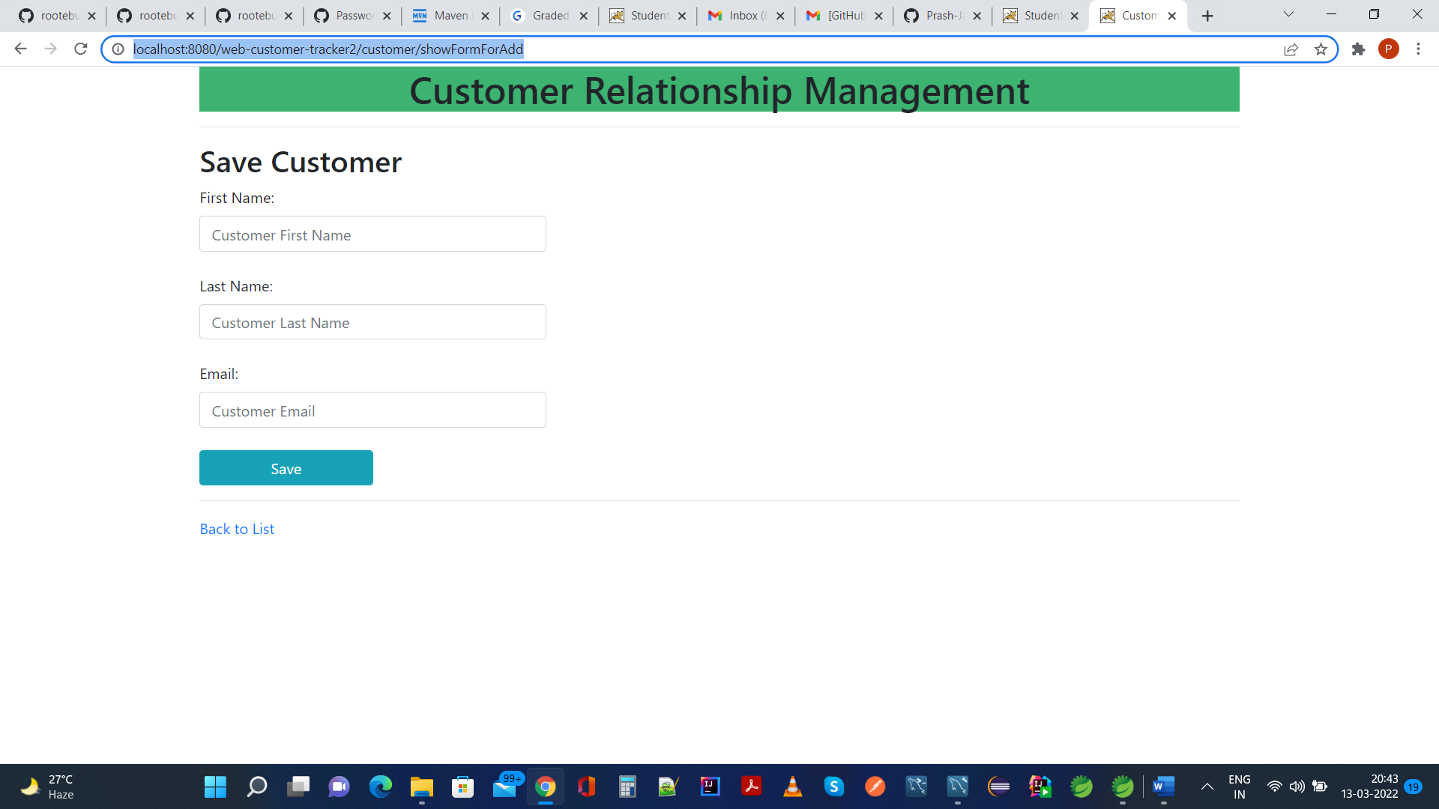

If we click on Back to list link, it would navigate us back to home page url as here,

<http://localhost:8080/web-customer-tracker2/customer/list>



Option b: if we click on update button for any row, it will navigate to following url based on customer id:

<http://localhost:8080/web-customer-tracker2/customer/showFormForUpdate?customerId=2>

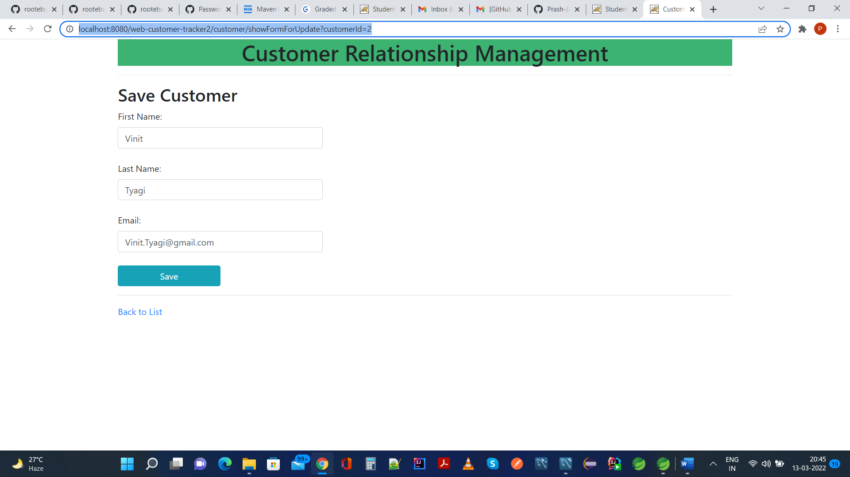

If we click on Back to list link, it would navigate us back to home page url as here,

<http://localhost:8080/web-customer-tracker2/customer/list>



Update Operation: We would perform update operation on 1st row and the same would be reflected in UI and DB as seen below: email of 2nd row customer is updated

<http://localhost:8080/web-customer-tracker2/customer/showFormForUpdate?customerId=2>

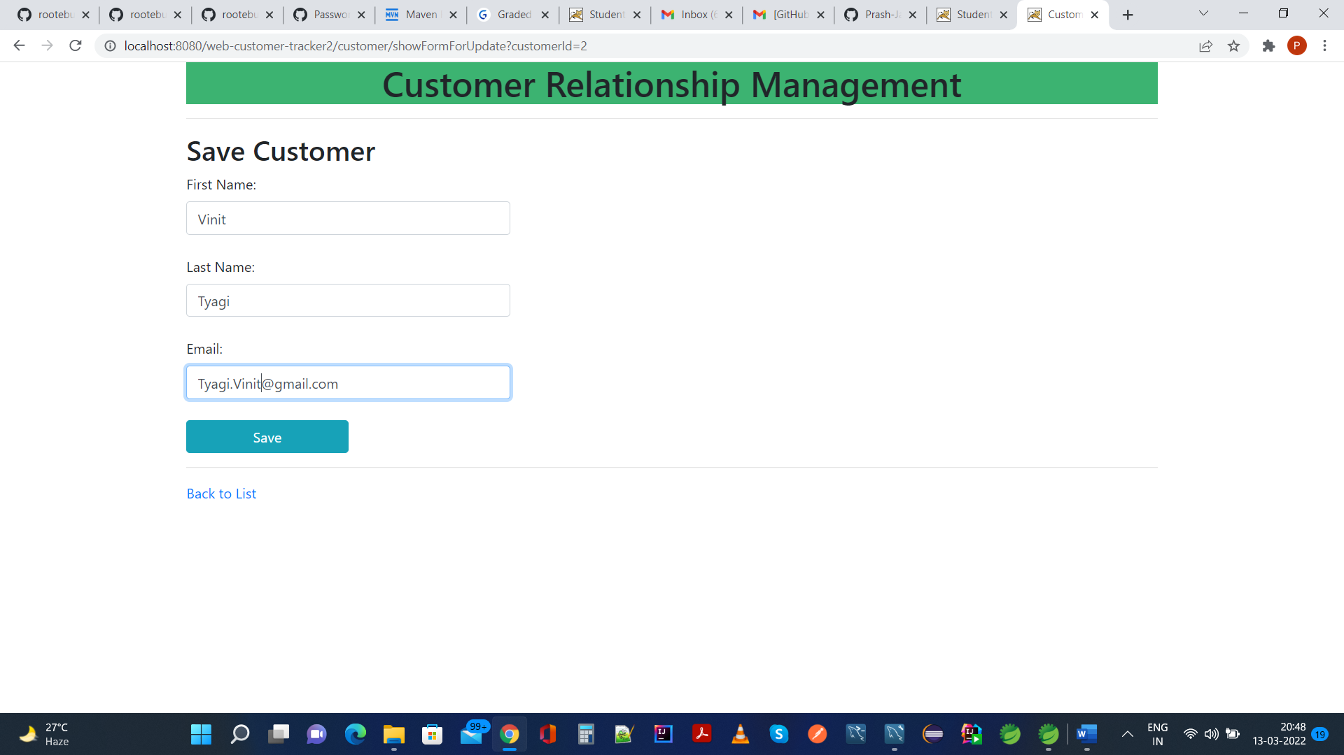

Clicking on Save button would navigate us back on home page

<http://localhost:8080/web-customer-tracker2/customer/list>

As we can see, email of 2nd customer is updated,



The same can be seen in MySQL DB as well,

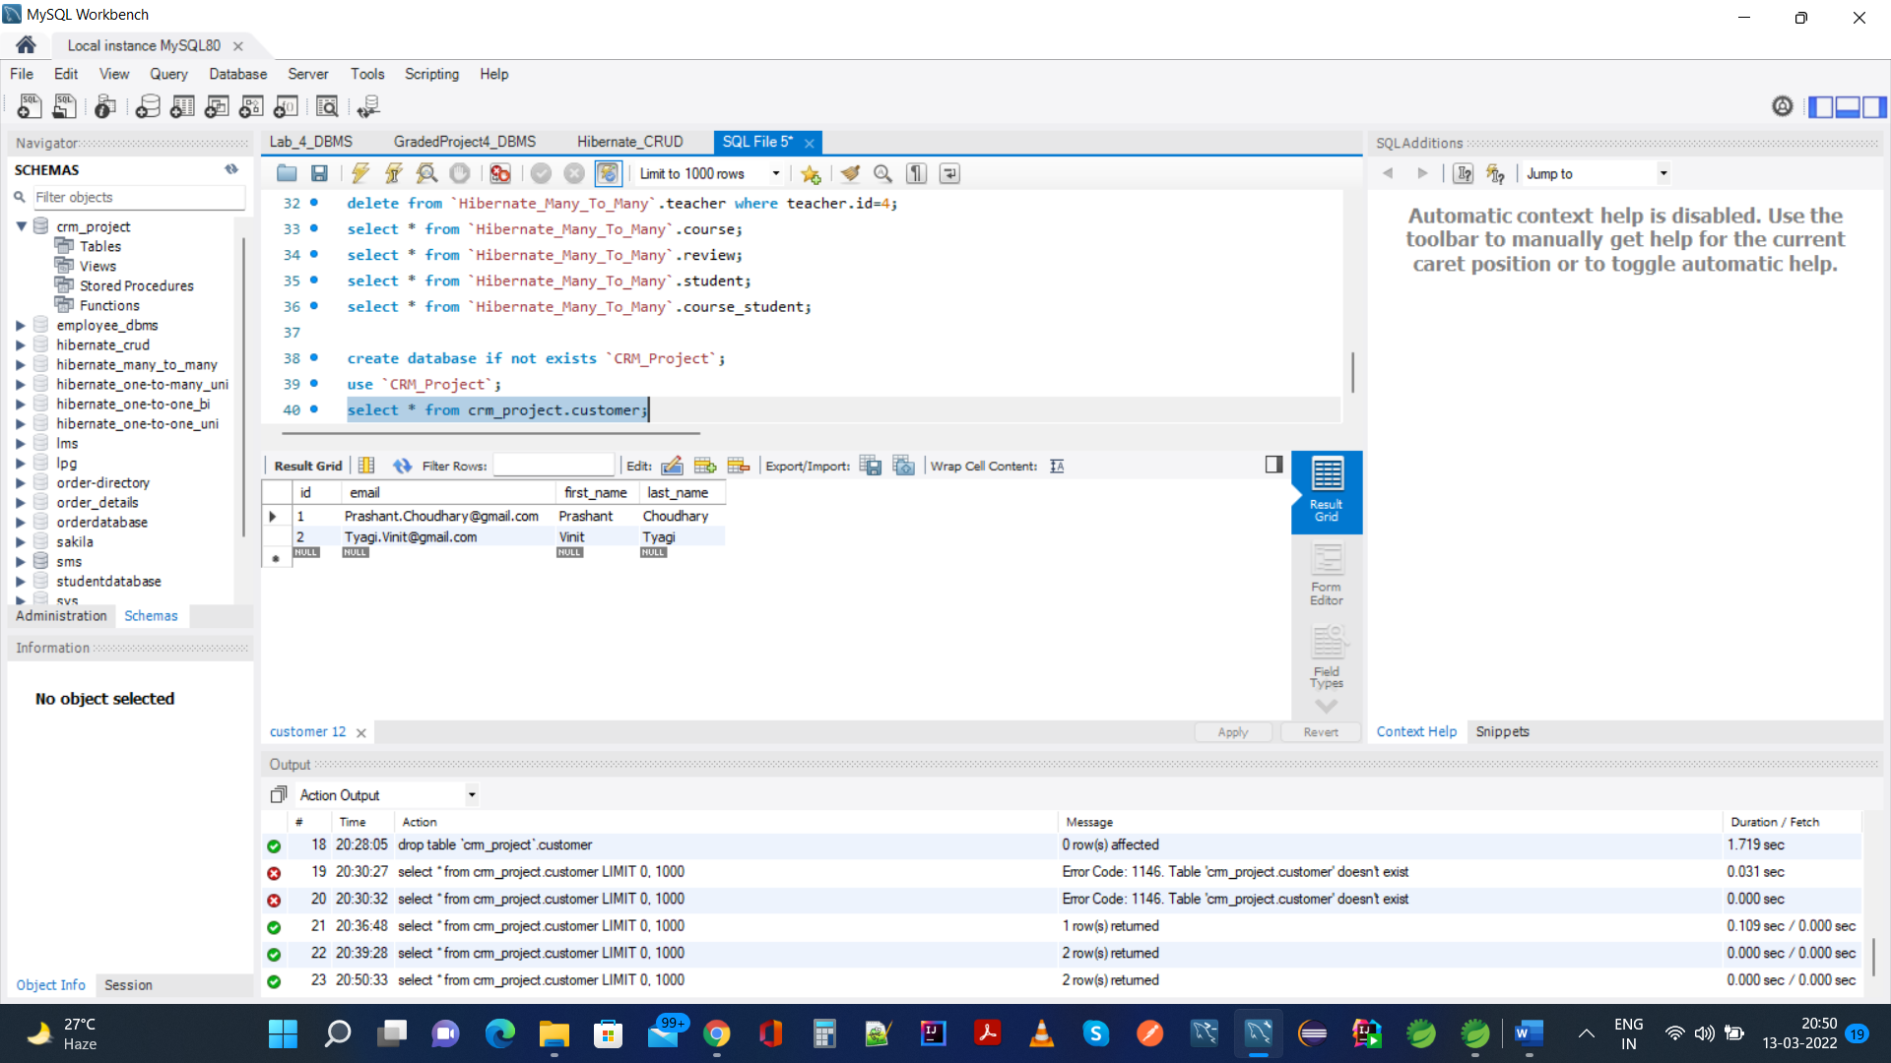

Delete Operation:

We would be deleting 2nd row in the list from UI,

<http://localhost:8080/web-customer-tracker2/customer/list>

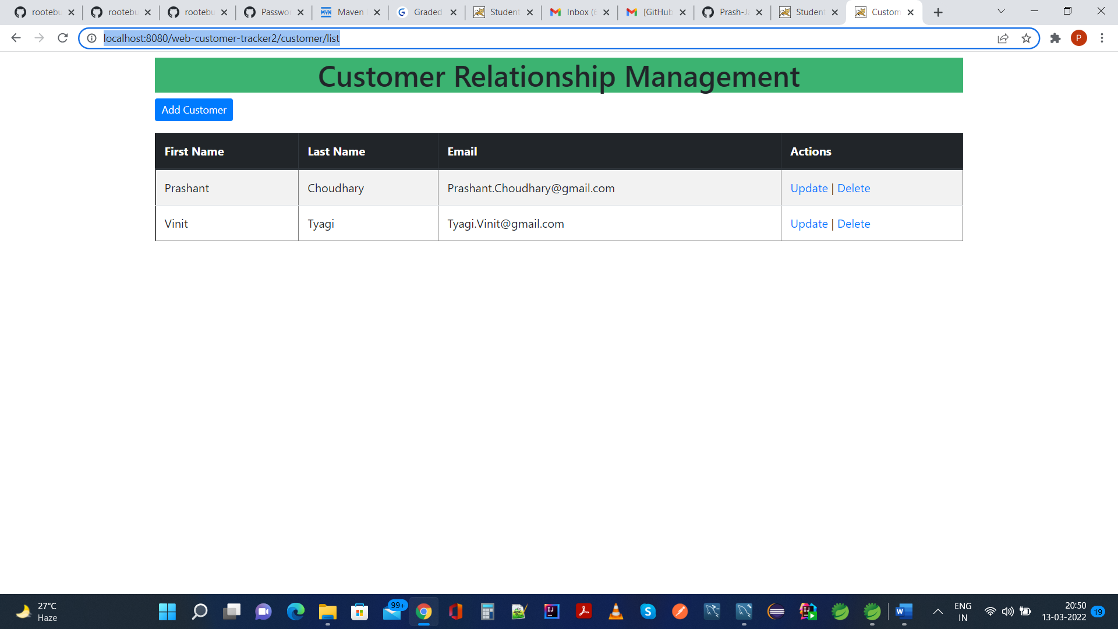

On clicking delete button, js event onclick is called which provides the modal dialog confirming delete operation,

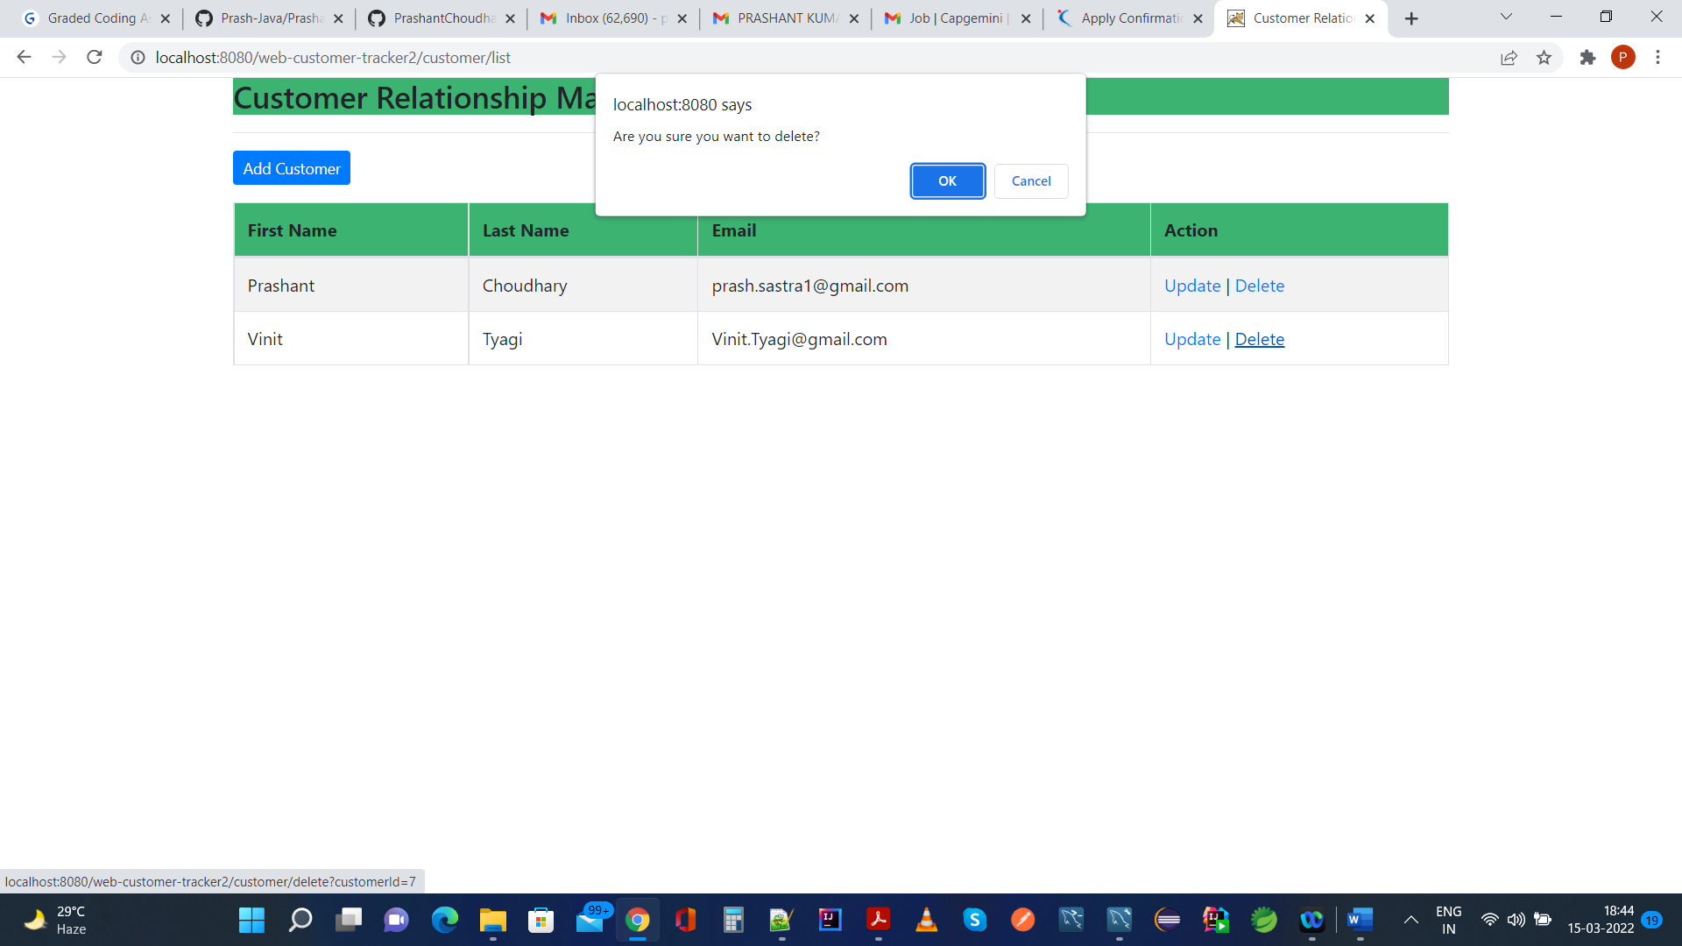

If we click cancel on modal dialog, there is no change and we remain on same page with all rows intact,

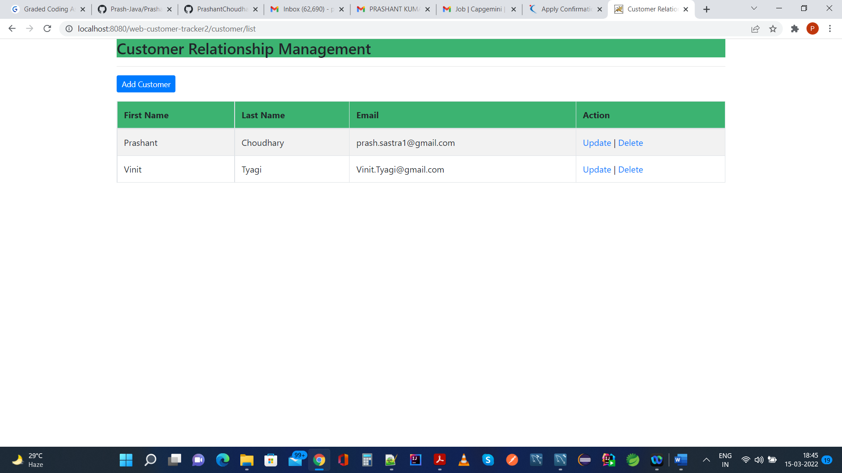

No change in MySQL DB as well,

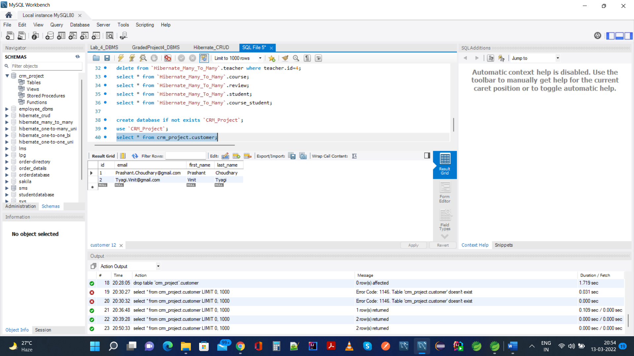

If we click on ok button in modal dialog, it will delete the selected row and this will be seen below both at UI and MySQL DB,

Deleting 2nd Row,

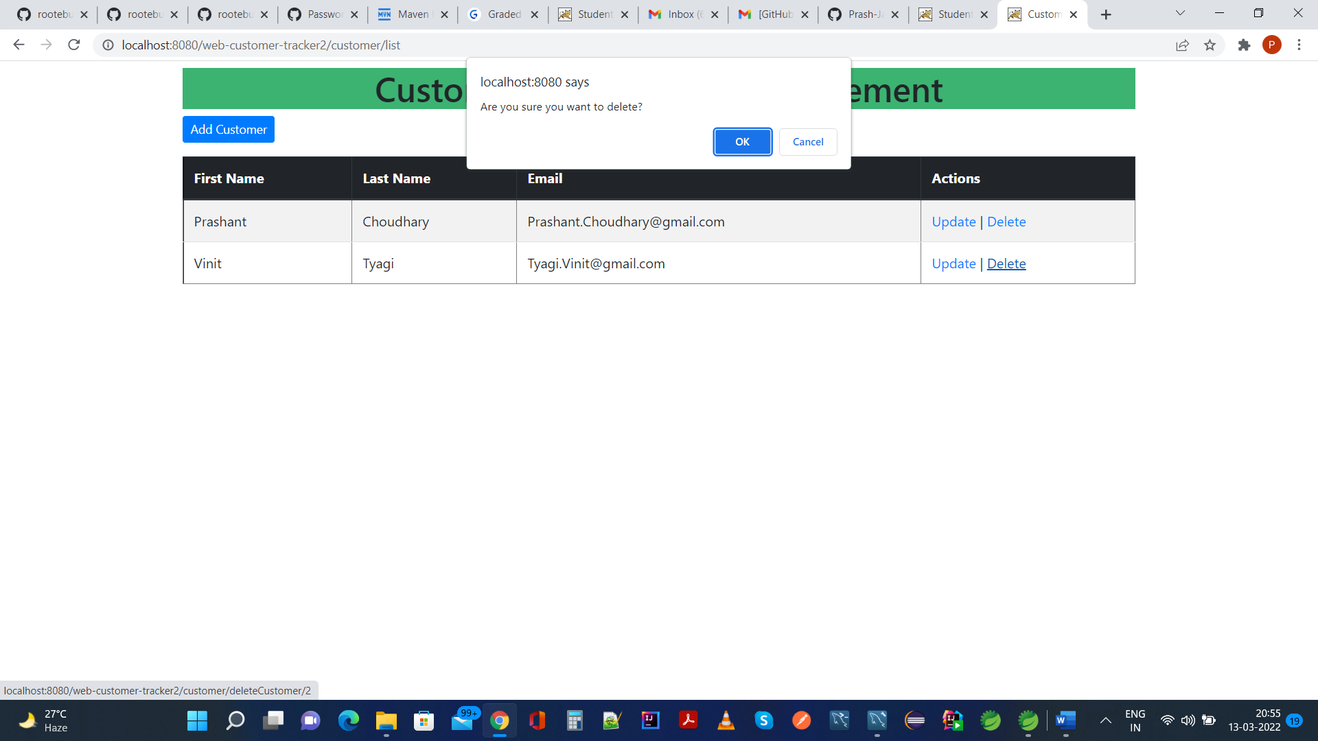

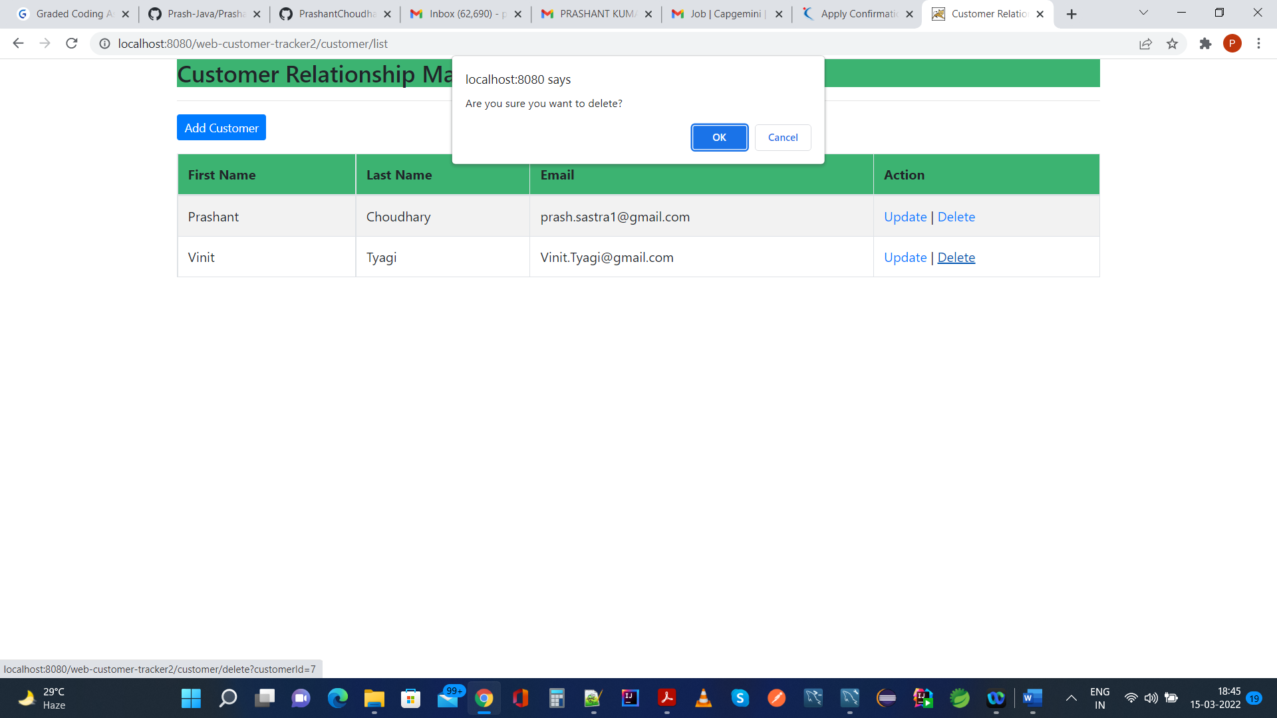

After Clicking On OK Button on modal popup during Delete operations, screenshot is below,

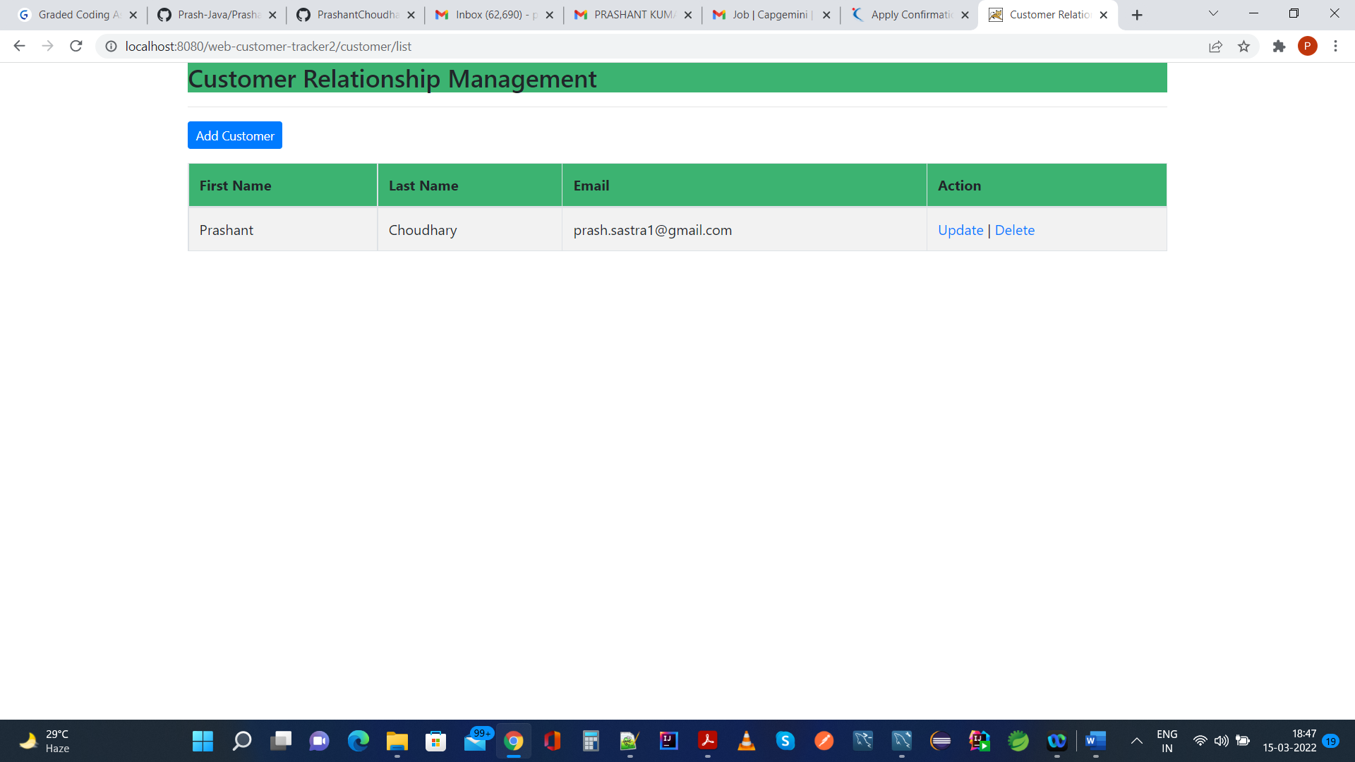

In MySQL DB,

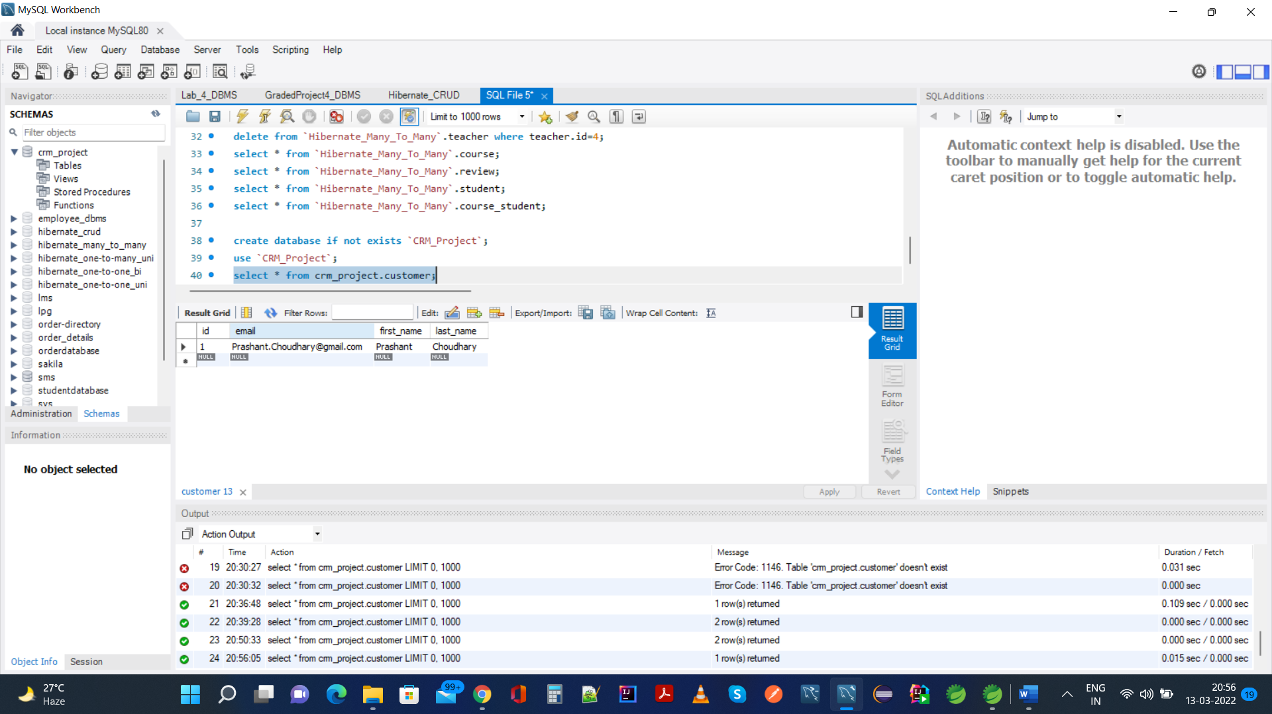

All Operations On DB Query From Spring MVC Console can be seen here for reference,

